Bu

PROTON ELIC RB-I MODEL 5

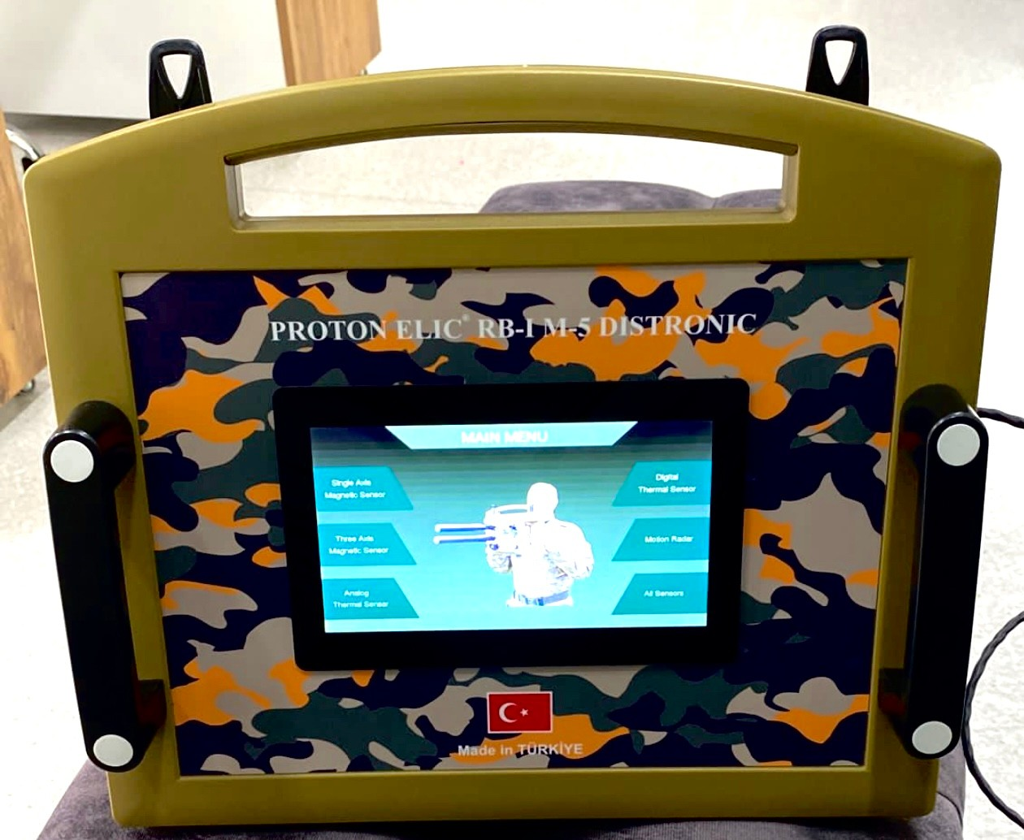

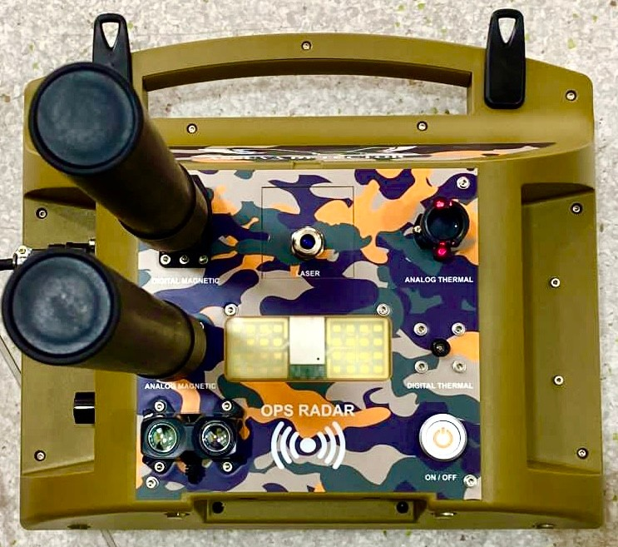

User guide "DETAILED BOOKLET"

WHATSAPP CONTACT FOR SALE:
+90 535 040 00 30

IMPORTANT WARNING
Our company is not held responsible for any usage or mistakes made in this booklet. The slightest change to be made outside of the authorized service will lead to the cancellation of the firm's warranty for 2 years. Mechanical power fuse inside the device will cut the power

of the device and cause software cancellation.
If the back or front cover of the device is opened, both firm warranty and software fee will be requested from the invoice owner. The device is protected by the copyright laws of the Republic of Turkey. Copying or trying to copy is a legal crime. He is punished with heavy compensation and prison sentences. Our company is not responsible for the items listed below.

- Damage to the Instrument Head unit or forced to open intentionally.
-Device Apparatus damaged or replaced with another product.
-Changes or destructions made outside the authorized service.
-Using the computer supplied with the device for other purposes and damaging the software.
-Deficiencies or spyware that may occur in the software file.
-Opening of the Sensors of the device or all internal / external damage.
- In case the device is exposed to High Magnetic.
- In case of force or opening of the sensor

inputs and Connectors.
-In case of Device or Computer Fall.
-User-Oriented Rotate or Breakage in Sensors.
-If the device and all parts are subjected to pressure or water.
All interventions (including dropping and water intake) that can be done externally to the device, in case of tampering and confusion of software files, and secondary parties do not have a license key. When another user buys, he /she just bought product and the license key.

ASSUVA DEFENSE INDUSTRY'S NOTICE TO DEVICE USERS
CONTENT

PREPARATION
SENSOR INTRODUCTION AND ISSUES MAIN UNIT INTRODUCTION AND
ISSUES
B AT T E RY A N D P O W E R C A B L E

INTRODUCTION AND ISSUES CARRYING BAG AND COMPUTER BAG ISSUES
SOFTWARE ISSUES INSTALLATION BEFORE YOU START WHAT TO DO SHOOTING EXAMPLES

Congratulations You have acquired a professional device, and it is very little to reach your goals and goals.

PREPARATORY
Before starting, watch detailed installation setup video.
The device consists of two carrying bags. Waterproof G-Shock Carrying Case contains Device Computer, Main Unit, Sensor Probe, Power cable, Power bank, Power bank Charger, Neck suspension device, User manual

The Back-Carry Bag is produced for a Comfortable Use with its Special Camouflage and Waterproof structure.

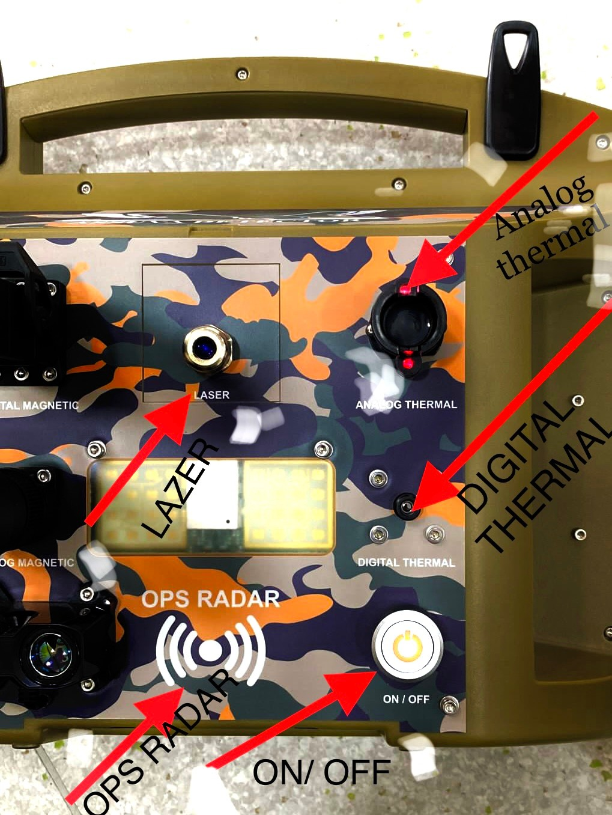

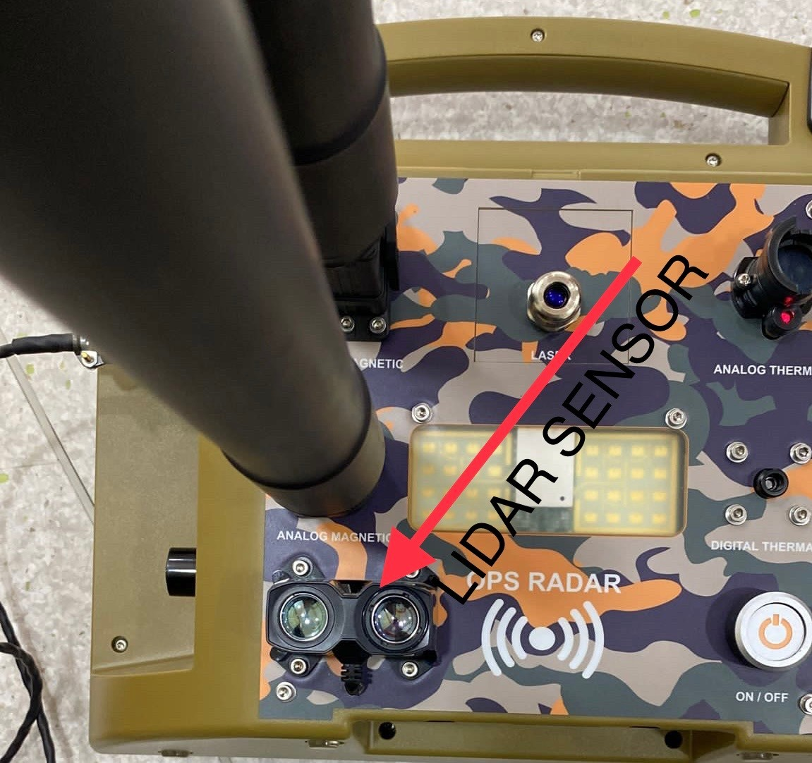

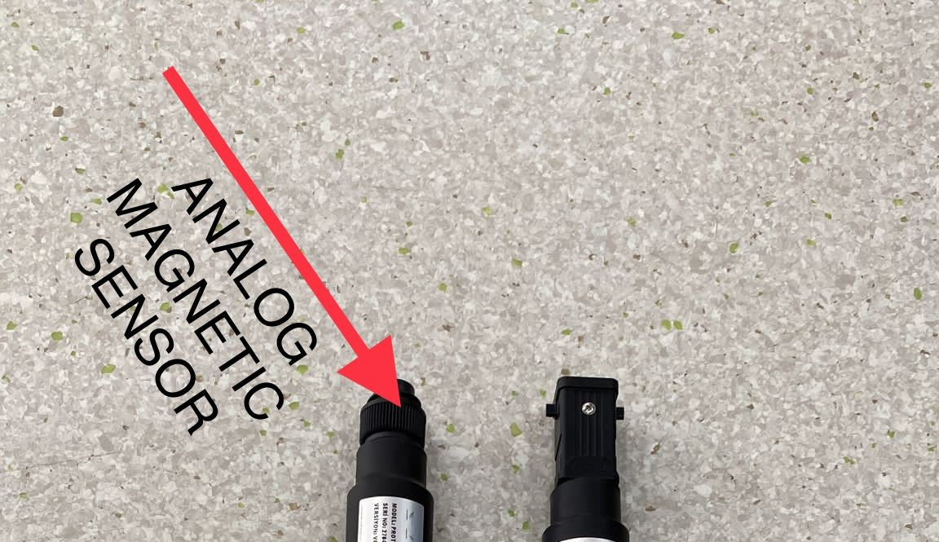

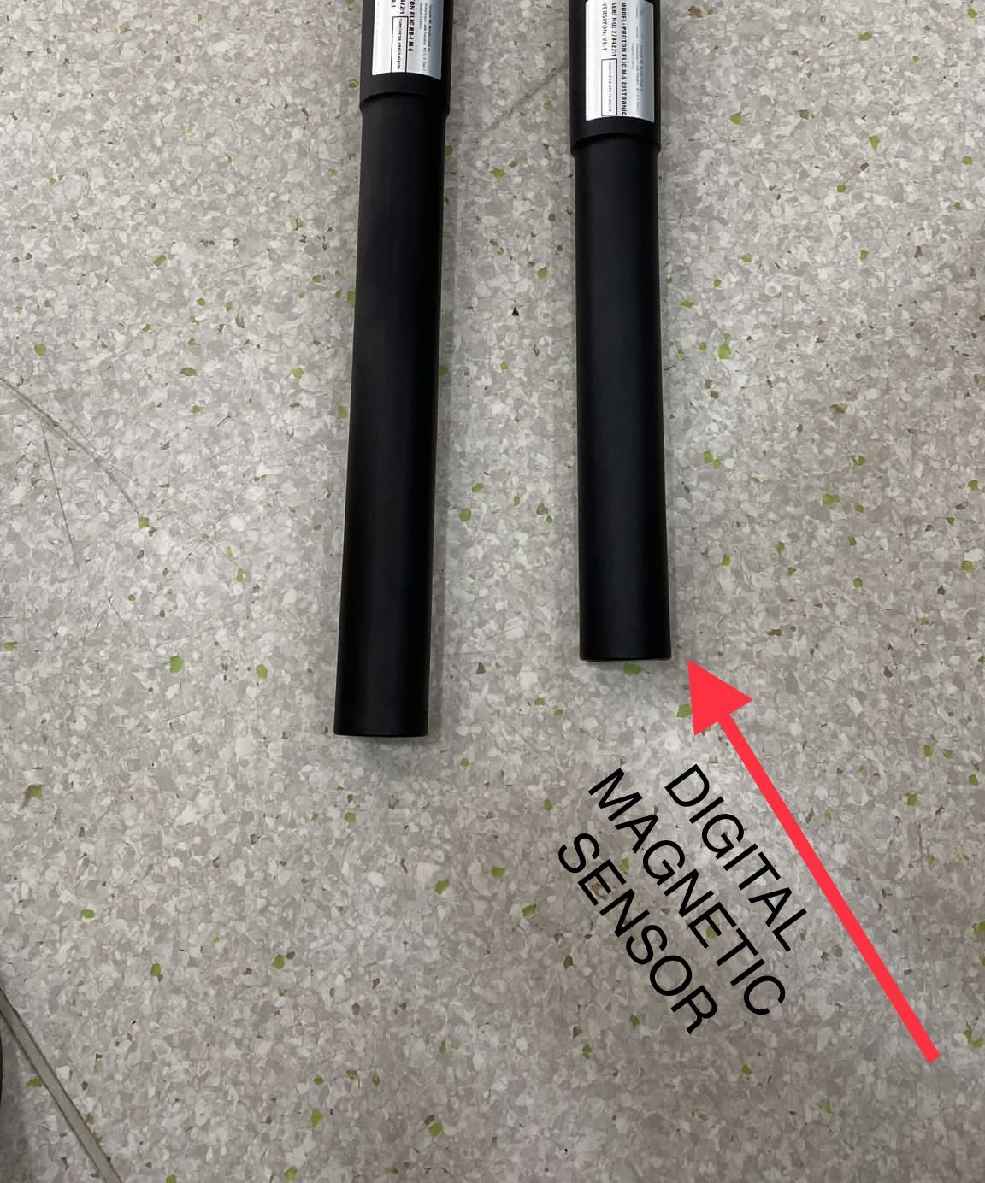

SENSOR IDENTIFICATION AND ISSUES
The Sensor Assembly consists of one main part. It has a matte black and solid form. There are two sensors in the probe, consisting of three axes in the probe and one axis sensor. It

is fixed with a processor card on a special CNC machined socket. It has been prepared by controlling step by step through the steps produced with meticulousness in our facilities.

WARNING!
The sensor must be turned without forcing from the swivel connector mentioned above. Otherwise, it is inevitable to change the sensor direction or damage the sensor. It is an intervention that is not covered by the warranty and is designed to be understood in case of false conversions.

HOME UNIT INTRODUCTION AND ISSUES
- 64 Px Thermal Snapshot System (LIVE HD)
- Continuous Wave Laser Pointer (Point Plus
+)
- Doppler Camera Superior Object Detection system
- Connector Output Sensor Area to be installed (ST system)
- Lidar V3 Lite Optical Rangefinder and

Surface Cleaner (Ray Technology)
- Thermal / Magnetic Toggle Switch (Lever Plus +)
- On / Off button (Spring System)
- OPS RADAR
- Analog Magnetic sensor 10.Digital Magnetic sensor
- Thermal sensor
- Thermal Camera
13.800x480 capacity touchable screen
- Optic lidar feature
- Anomaly detection with analog thermal sensor
- Choosing sensor option one by one
- Doppler Radar
- Location and speed detection

ACCESSORIES
- Reset Button Optical Value Balancing (Value Tech)
- Touch LCD Control Screen (LCD +)
- Operation Lamp Inspection Light (LED
+)
- Laser On / Off Button Protected (Guard +)

- Power Cable Connection Output Connector (ST system)
- Thermal Insurance Current Protection System (M +)
- Neck Hanger Attachment Attach / Remove (Lock +)
- Neck Strap Bracket Clamp Assembly for Plug / Unlock (Lock +)
Neck Strap Apparatus is a device that helps long walks and the device stretched steadily. It is recommended to use.

BATTERY POWER CABLE INTRODUCTION AND ISSUES

- Power Bank Power Supply (30,000MAh)
- Out 1 USB Power Cable to be Plugged in and Under Charge Input (Type C)
- Out 2 USB Power Cable to be Plugged in and Under Charge Input (Type A)
- Device Connector Input Part to be Connected to the Main Unit (ST system)
- USB port to Connect to Power Bank (Type A)

CARRYING BAGS AND MATTERS

- Multi-Purpose Camouflage Backpack Supplied with the Device.
- Carrying Case G-Shock (Ultra +)

Country of Origin: Turkey
Professional Tool Bag with Waterproof, Shockproof Hard Surface
Mad Raw Material: Custom Made High Impact Copolymer Pp
Atmos Atmospheric Pressure Effect in Seals Provides Sealing, Does Not Allow Dust Inlet, Gaskets Acts as Barriers Against Possible Damage Effects of Substances Like Air and Water

WARNING!
(You can request in Green and Black Color. It will be provided according to Stock Status.
Computer Neck Strap bag and Carrying Bag
It is produced with zipper from compact and high-quality material.

LET’S INTRODUCE M5 SCREEN

M5 has two types of magnetic scanning and two types of digital sensor.

- SINGLE AXIS MAGNETIC SCANNING OPTION ( ANALOG SENSOR)
- MULTIPLE ( WITH THREE AXIS ) MAGNETIC SCANNING ( DIGITAL SENSOR )
- ANALOG THERMAL SENSOR
- DIGITAL THERMAL SENSOR

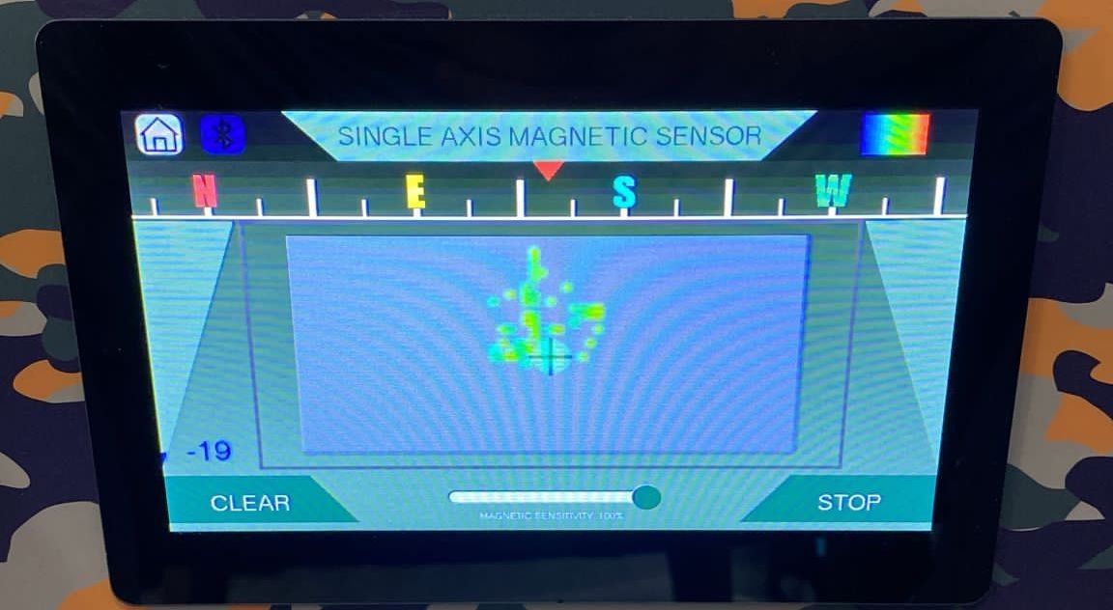
What Analog Magnetic sensor work for ?

This type of sensor can easily find all metal types and cavities like shelter, tunnel, room,

grave, tomb. It enables one-axis scanning. This type of sensor makes scanning only in one axis. It cannot see objects in 3axis.

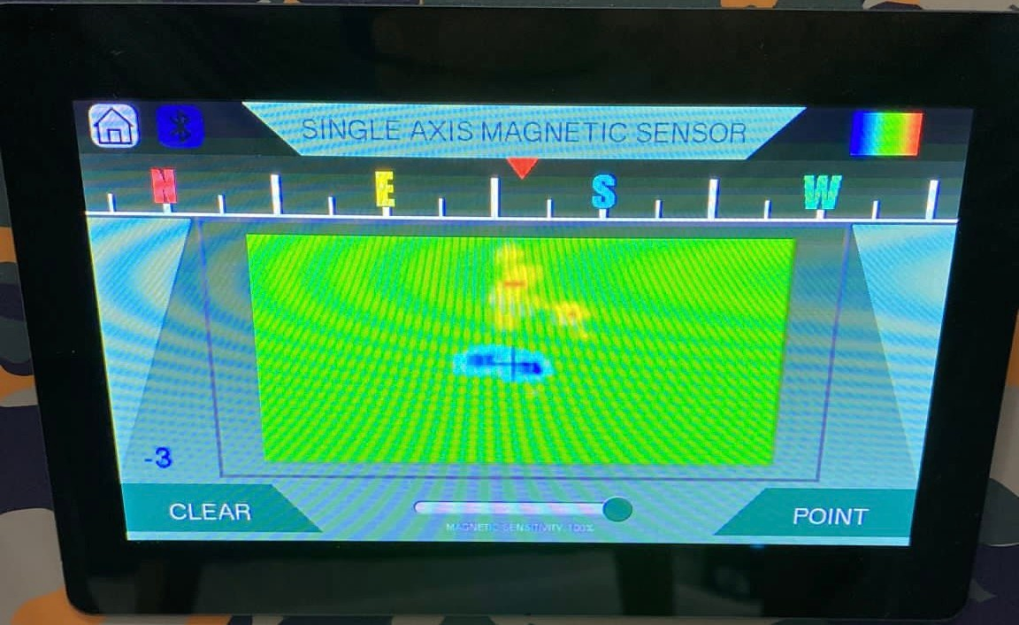
After you make your scanning, the image is seen like that..

What digital ( multiple) magnetic sensor works for ?

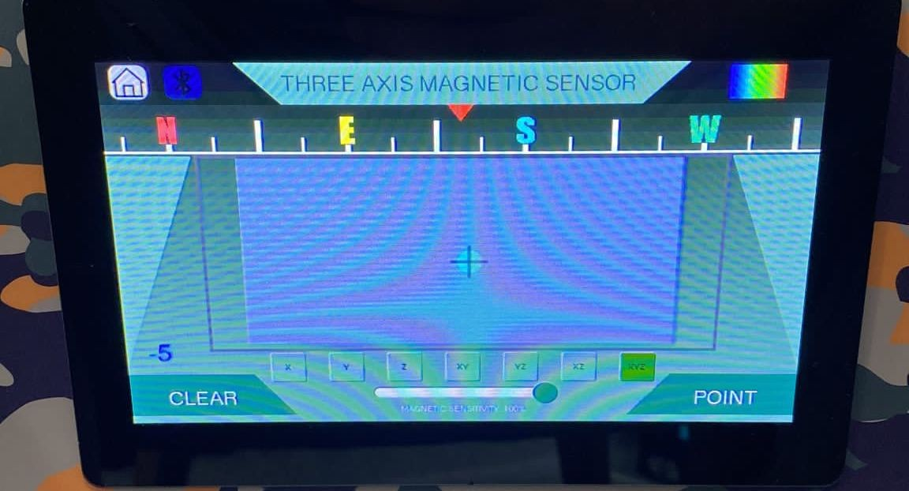
This type of sensor has 3 axis capability, it can easily scan in 3 direction at the same time. While you are scanning front, it can also scan right and left side at the same time.

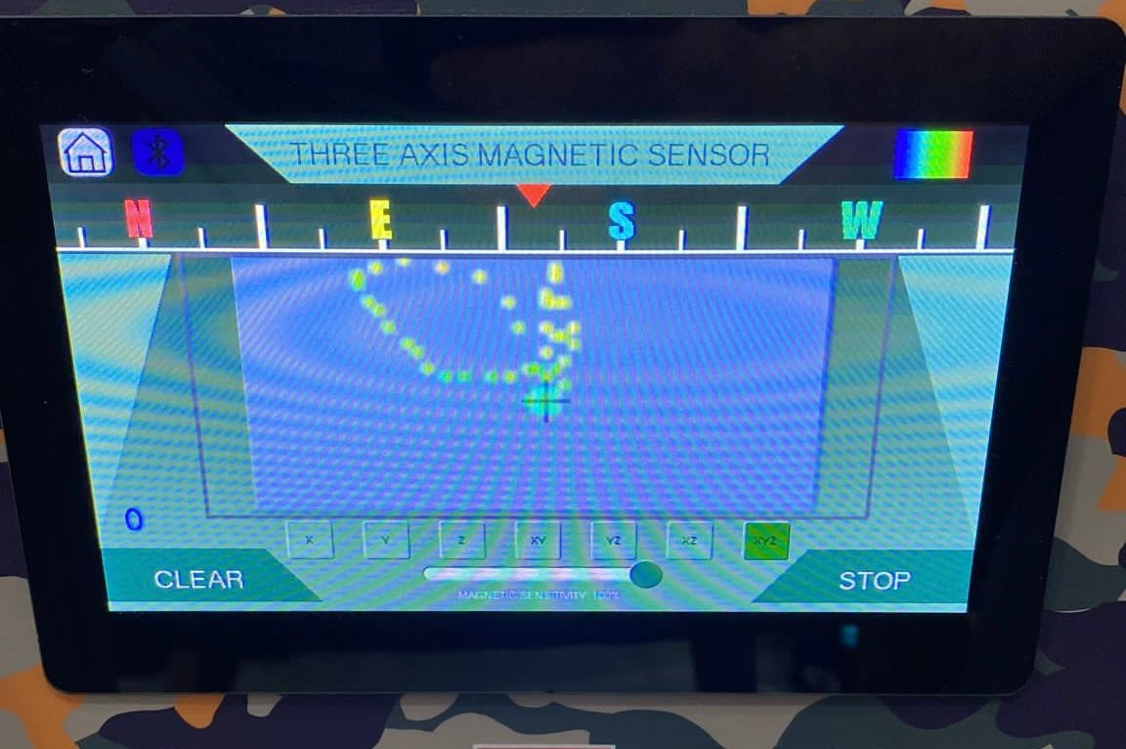

After you make your scanning, the image is seen like that..

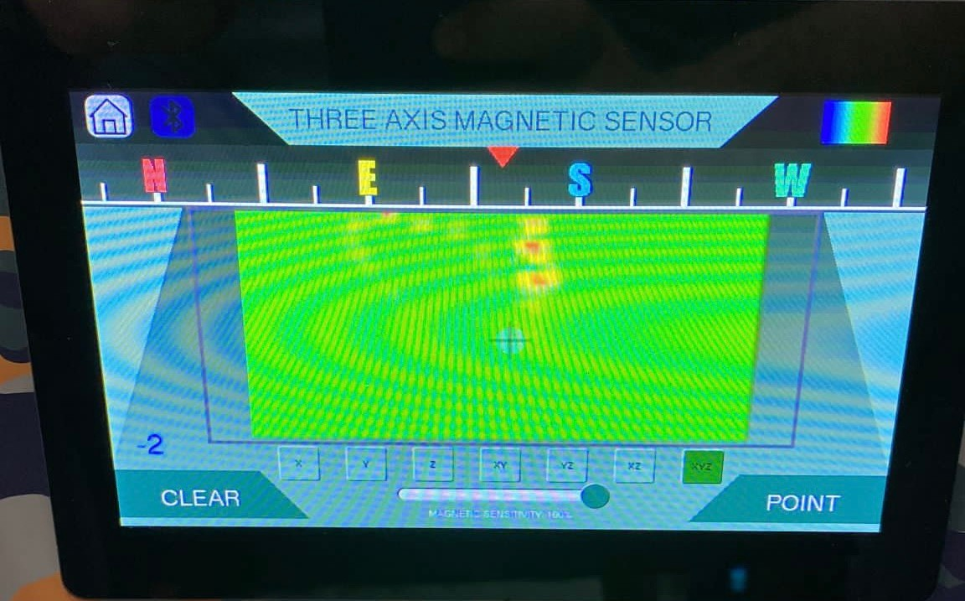

These are the positions that the device could scan at the same time.

F | R | O | N | T
R | I | G | H | T
LEFT





.

DIGITAL ( multiple) Magnetic Sensor makes your work easy, because it doesn’t show you ruins which has lower signal, this sensor shows you real cavities and unrotten metals which have high signals.

What analog thermal sensor works for ?
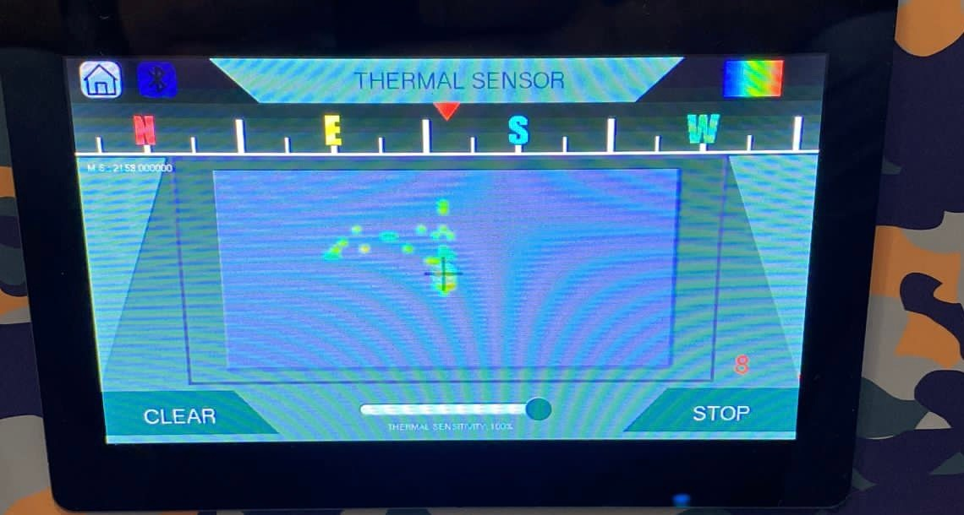
This sensor is used in wet ground or in snowy ground to find cavities, buried metals plastics ,papers, corpses.

After you make your scanning, the image is seen like that..

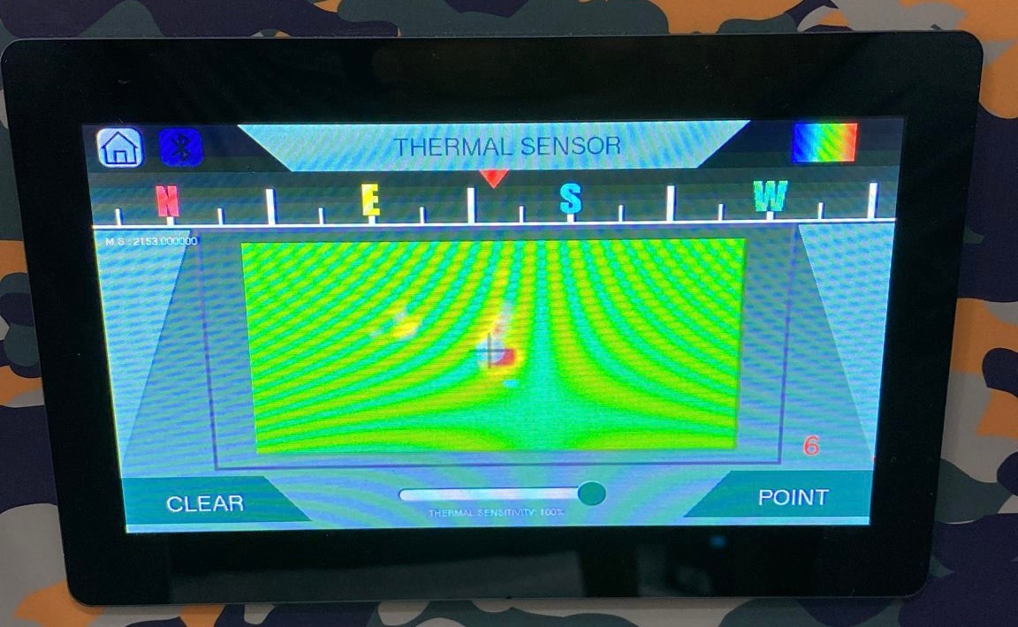

What digital thermal sensor works for ?
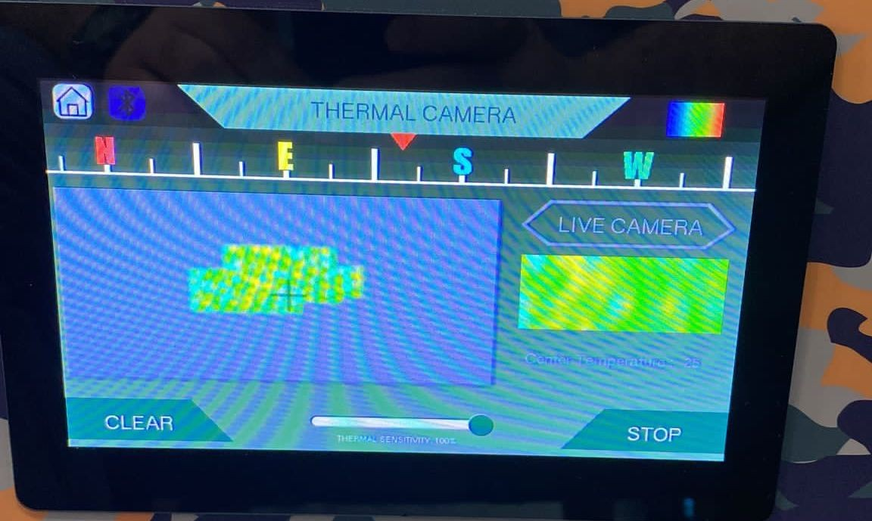
This sensor option is used for cavities and or living being which are close to surface ,and this sensor draws cavities with its route.

After you make your scanning, the image is seen like that..
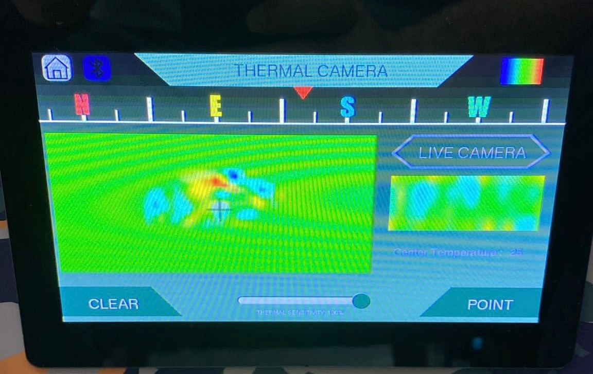

What OPS RADAR sensor works for ?

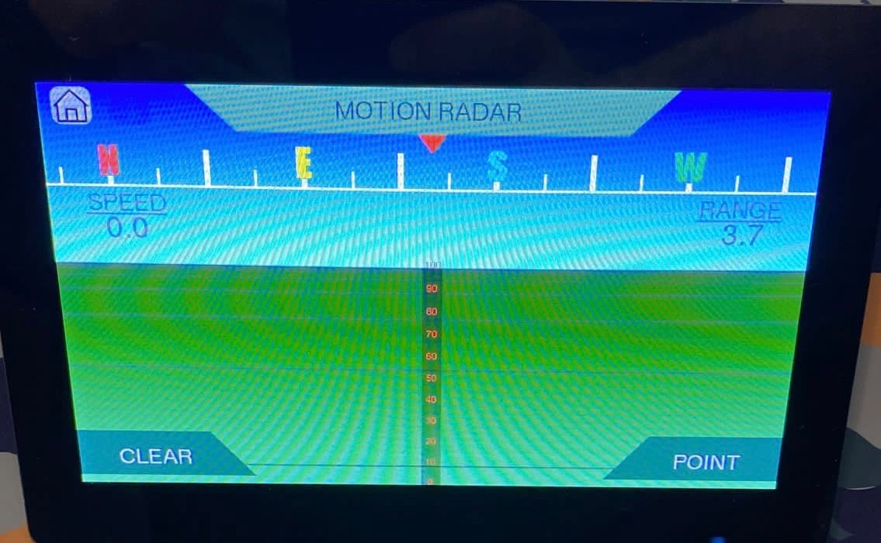
It can show you a movement of living creature in 50 meter distance far in a forest, or in the dark. To see this movement, you click ‘ START’ and you are going to see a cursor, this cursor shows the exact direction of living being. the cursor moves to the right when the movement of living being moves to right, or the cursor moves to the left when the movement of living being moves to the left. You can also see the speed of object.

What ‘’ALL SENSOR OPTION’’ works for ? You can see data of signal severity which is coming and combining from all sensor types. There is also stable 64 pixel thermal image on the screen.

When you choose ‘’ALL SENSOR OPTION , you are going to see bar system here , ( blue and red bar) ;
Blue bar goes down and it shows cavities, red bar goes up, and it shows metals.
As seen on the screen, you can see the Maximum and Minimum Temperature in the Area Instantly.
Thermal and Magnetic Sensitivity adjustment You can adjust the sensitivity individually by moving the circle bars at the bottom to the left or right with your hand.
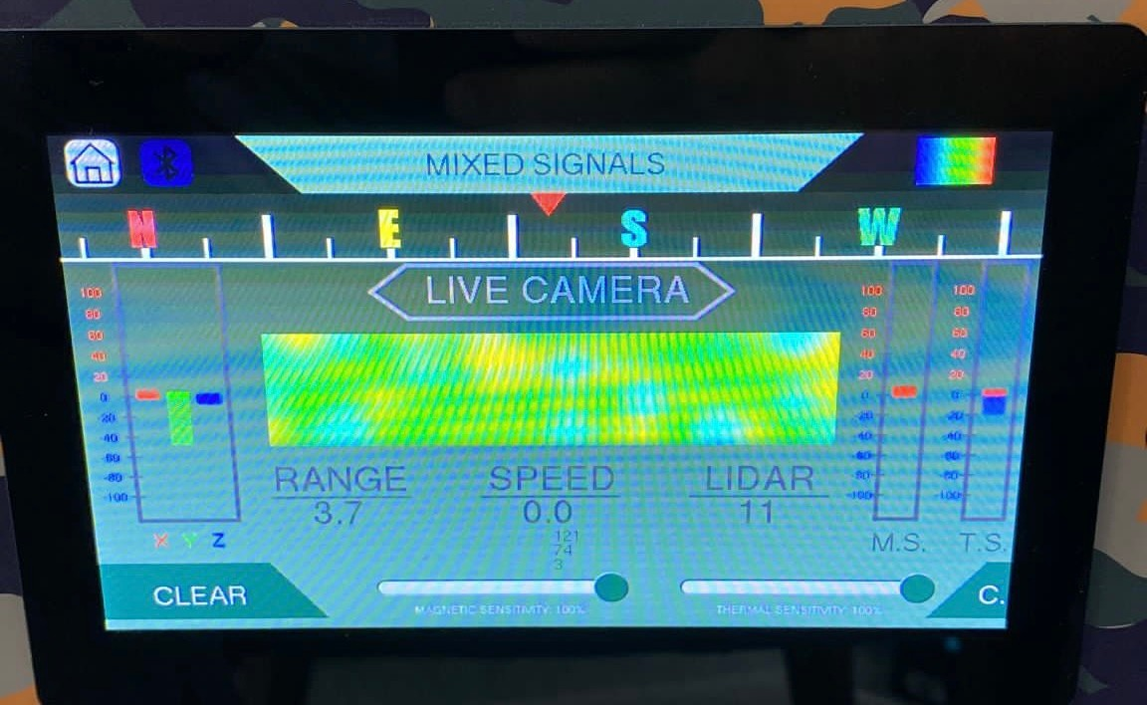

Screen Cleaning and

Protection

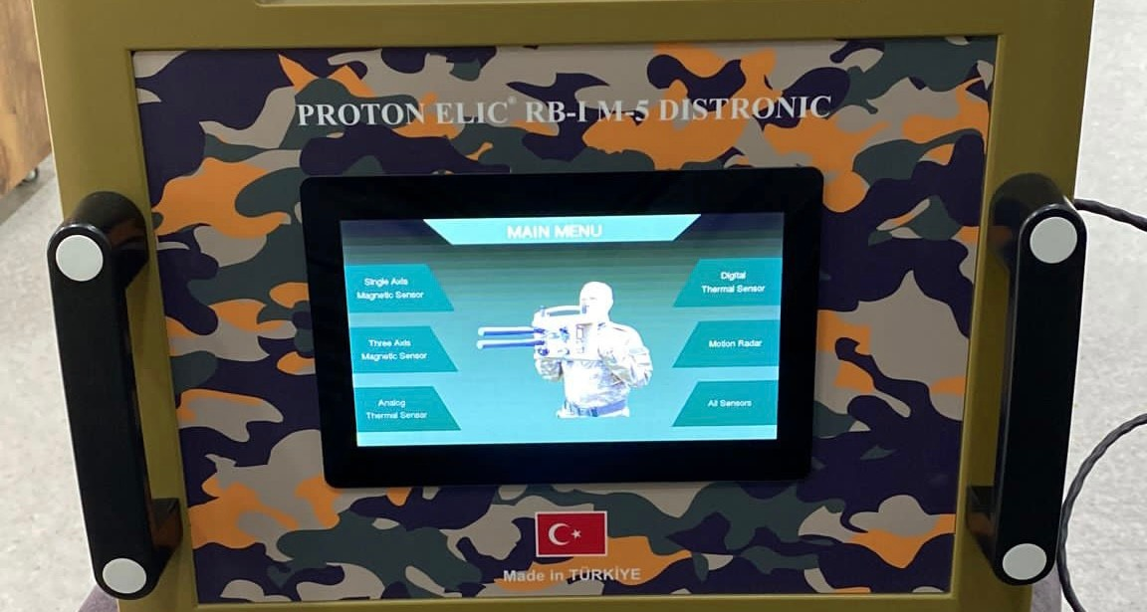

If the LCD touch screen is dirty, please clean it with a slightly damp cloth.
Do not touch the LCD touch screen with any liquid.
Keep away from sharp sharp objects that can press the LCD touch screen.
Do not pass the LCD touch screen from cold to warm.
If you are not using the device, disconnect the Main unit from the Power.

WARNING!
(Our Company is not responsible for user- caused breakage and malfunctions.)

MATTERS TO BE CONSIDERED BASIC PROTECTION CLEANING

- The Console and Lens of the Thermal Sensor should be protected from dust and effective contamination and should be cleaned with a dry cloth without damage, if soiled.
- Connector inlets on the device should be kept away from water, mud and dust, and cleaning with sharp-tipped materials should be avoided.
- The battery is 5v 30.000 MH Power Bank, which can be easily found anywhere in the world. However, the power cord must be obtained from our company. A repaired cable or a cable fitted with a fitting may cause the device to malfunction.
- Battery Charger can be charged with Universal Charger Type C and it can be charged in approximately 1-2 hours. If you do not use it, it is recommended to charge it once a week and it will increase the battery life.

- The device should not be carried by any other type besides the original carrying bag and should not be wrapped with Plastic derivatives. Do not expose the device to paint.
- The original G-Shock carrying Case of the device has Anti-Static feature, provides protection from harmful rays and high magnetic comply with the previous item.

SOFTWARE AND HARDWARE ISSUES

- Proton Elic RB-I M-5 has its own special software.
- You will have 3D software with the LCD screen located on the back of the Main Unit and 3D software with the PC you have received.
- The software is installed on the PC next to the LCD screen and the device. Secondary persons do not have software license rights. The language right of the person is limited to 3.
- Proton Elic 3D software works in real (realistic) according to Official Ground

Algorithm.
- Metal separation works understandable with distance depth and selectable color tones.
- You can record your shots with your software and review them at any time.
- If desired, you can punctuate with the GPS device of the region you have captured with the help of the GPS (Mapping) and Google Maps Mapping.
- It has recording feature for 4D Universal software (dat. Map. C.V.S..).

All software rights are protected by the copyright laws of the Republic of Turkey. In case of violation, forensic follow-up will be initiated.
When you open the software on the PC delivered to you, you will see the screen. You can choose which language you want to use. When your device is on via the Control Panel, connect the Com connection and wait for your device to connect for about a few seconds.

Com information is written on the PC. Com-3 may be like Com-4…. May vary…
If the GPS plug-in is available, you can view the captured coordinates on the Map by clicking the Show on Maps button.
You can adjust the Night / Day setting and Indoor-Outdoor setting according to your current situation.
You can customize the Color Settings in a way that you can understand. We deliver to you with the most understandable color setting.
Adjust the soil settings according to the soil structure. Depending on the soil structure, depth can vary.
You can check your program version. Compatible software has been installed on your device.
Make sure that the -0- point stays there after starting the shooting for an ideal shot, if it does not come, press and hold the reset button for 1 second and it will recover.
In this representative image, the increase in the value scale of the space downwards indicates that the space is 40% free compared to its value. The shooting structure is below.
Depending on the condition of the structures,

the quality of the visual shooting can vary.You can easily save your shots by clicking the save button.
INSTALLATION ISSUES

PROTON ELIC M-5 comes to you in a calibrated situation, if you push ‘’K’’ button mistakenly, you should calibrate it again, the calibration method video will be given by your provider.
Device Setup is simple. Make sure that the connector is fully seated when installing. There is a protection thread in the connectors, and it will not sit in the connector slot unless it is properly installed.
Insert the Digital Sensor into the Sensor Connector socket with the Thread seated and tighten it gently. Tightening too tightly may damage the connector thread.
*Power Cord Connector Slot Power Cord Connector
Insert the power cable connector into the Power cable connector socket on the right side of the Main unit so that the Thread is seated and tighten it gently. Turning it too tight may

damage the connector. Turning the power cord connector through the cable section may damage the cable. Incorrect power delivery to your device can lead to problems such as low travel. Do not repair the cable or change it yourself. You can contact us and get a new one. Damages that the repaired cable or Unauthorized Modified Cable may cause to the Device belong to the user. The warranty for 2 years terminates.

*Power Bank Power Supply Power Cable USB type A
You can use any of the USB ports on the Power Bank Power Supply. Plug the Power Cable Type A USB Port into the Power Bank USB port. Check the Charge of Power Bank Power Supply. Charge 2 Hours After Receiving and Charge Normally Every 2 Weeks.
You can use the Neck Strap Apparatus according to your requests. It Is Auxiliary Apparatus Built to Support You.

Congratulations You Have Complete the Installation! You can now turn on your

device's on / Off button and start Thermal or Magnetic Shooting .

BEFORE YOU START
The PC battery status and Power Bank Battery status should be checked before starting Scanning with the Device. It will be a convenience for you in the field if you use the batteries with a fully charged Power Bank and PC to use the device.
Before starting the scan, the eye to be scanned should be checked in the area to be scanned and which points should be determined. Rather than Scanning the Whole Area, it is more logical to take it apart and shoot it piece by piece.
In this area, heights and falls should be determined and the position to be scanned should be adjusted.
“In some areas, you should find a higher place on the Range Out, that is, out of the scanning area, and shoot as far down as possible.” While shooting, you should set your proper place and shoot. It is essential not to forget your compatibility with the device.

You can take advantage of our Doctrines we have prepared for you and we will give you our recommendations on a sub-page…

Proton Elic RB-I M-5 Doctrine Training:

- Geographical use
- Geological structure detection
- Historical Formations detection
- Historical burials or ruins
- Industrial Research (Pipes, Cables etc.)
- Law Enforcement Studies (Corpse, Embedded Weapon and Ammunition, Document Tunnel etc.)
- Embedded Explosive detection (buried Mortar shells etc.)
- Shipwreck and shipwreck surveys
- Geological ground analysis, soil differences and magnetic field measurements

WHAT TO DO?
Before performing a quality scan, the air temperature in the area can affect the type of

scan and the result. Also if there is earthquake in your country, you shouldn’t use the device for 4-5 days until the surface becomes stable.
For example: Magnetic scanning may not work well on snowy and icy ground. We point out that it would be right to shoot with a thermal sensor in this weather condition. The reason will be the possibility of finding the location of the metal or cavity more easily in any temperature difference.
It will be an effective result for you to get help from the thermal sensor in underwater scans. Magnetic Sensor can work in all weather conditions and soil conditions. Thermal is our recommendation only in certain situations.

Distance calibration is very important.
The correct results of the device are in the hands of the user.
User at Point 0.
You need to set a target 5 meters ahead.
When you hold the device from 0 position to your target, you will find the correct holding angle of your device when it writes 5 meters in the distance section and you shoot at that position, do not shoot the targets below 5

meters.

Warning: The two distance measurements may sometimes not be the same, this may be due to the holding angle and the Lidar touching an obstacle. Do not worry about this situation. It works in two distance measurements.

The only purpose of the lidar sensor is not distance measurement. Lidar sensor will automatically adapt the surface analysis of the device with high emission rays. You can have detailed data. Lidar must be clean and kept away from cutting materials.
Lidar Technology has the superior surface definition as in the picture above. Again, a Lidar example, as can be seen, surface reading is in the middle.

DEVICE SCANNING FORMS
A-Outdoor B-Interior C-Night
E-Day

F-Thermal 64 Px
G-Magnetic Three-axis scanning Expansions and Definitions
A-Outdoor

Outdoor shooting is selected from the Control Panel of the software. Outdoor scanning is suitable for high slope straight or low slope areas. When
the slope limit is exceeded, Range Out will appear on the PC screen. If there is no possibility, Indoor can be selected if you cannot go up the slope.The slope example is as above, the 10% limit should not be exceeded.

B- Interior

For shooting inside structures such as the cave and tunnel in the photo above.
For indoor shots, you can shoot 360 degrees up to the ceiling and floor of the photos above. If you wish and if the slope is suitable, you can also do it as an outdoor.

C-Night Mode
This option is for the device to adapt to the magnetic difference when it is night.

D-DAY MODE

There are magnetic differences in day or in a night. Day and night shots should be chosen during day and night shots.
At the same time, you can adjust sensitivity and change color, and you can have a more stable image by resetting.
In thermal scanning, it is advantageous that the ground is snowy and frost. Especially your shooting preferences will be right to do between 01:00 and 05:00 at night.

This scanning mode is suitable for scanning in any ground condition. Proton Elic RB-I M5 is an innovative device by combining all sensor types that has been renewed and fully autonomous algorithm. Magnetic mode provides a stable phase reading with magnetic field difference measurement. It measures the magnetic intensity and ion electrons of an

object, allowing you to get a clear result. Thanks to the magnetic effect on the world, value and depth measurement can be made for the Object.

Shooting Examples

This section will show the shots made and the angle at which they should be shot.

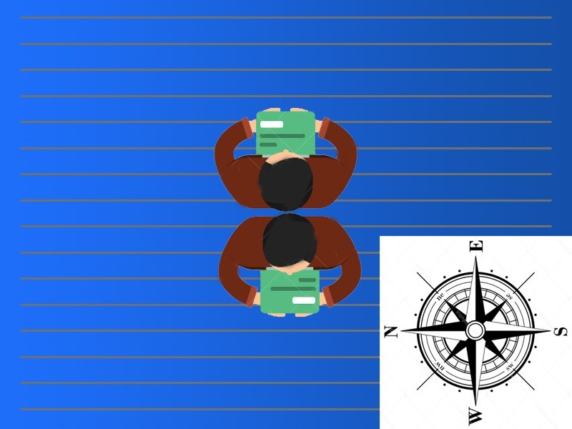

PROTON ELIC SOFTWARE SCANNING

EXAMPLES ON THE COMPUTER

After you choose ‘’PROTON ‘’ device from blutooth list, it wants a password from you; the bluetooth password is 1234. After it is connected; you are ready to scan. Here are some scanning examples.

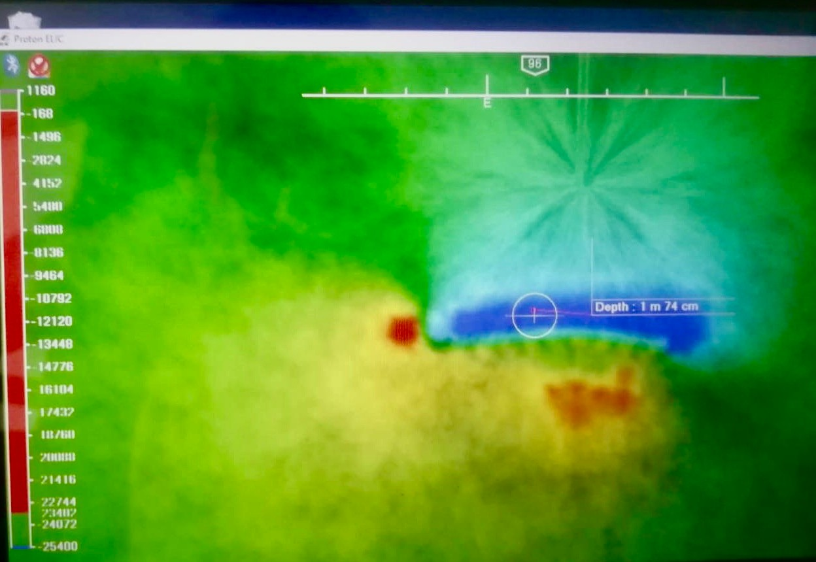

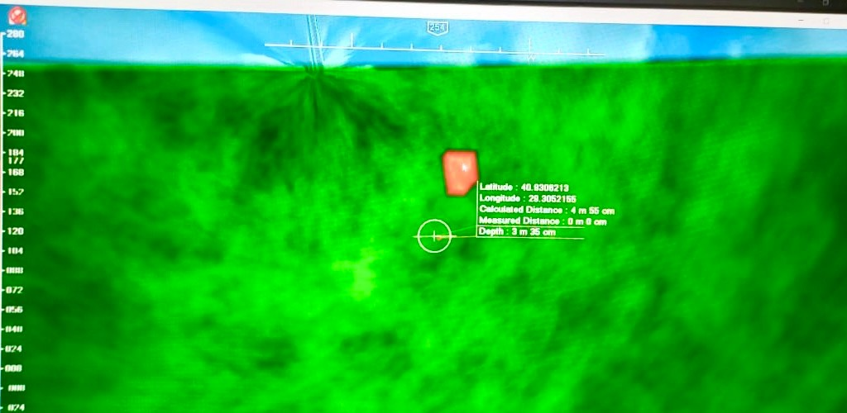

Let’s glance at scale values on computer…
ANALOG MAGNETIC SENSOR 29.000 ------- 31,000 GOLD
27,000 ------- 29,000 SILVER AND DERIVATIVES
15,000 ------- 29,000 COPPER OR BRONZE

Under 15,000—— IRON
0 ————— - 28000 FOR CAVITIES DIGITAL MAGNETIC SENSOR
29.000 ------- 31,000 GOLD METALS 0,24C…. SMO
27,000 ------- 29,000 SILVER AND DERIVATIVES
15,000 ------- 29,000 COPPER OR BRONZE
Under these values, IRON
0 ————— - 28000 FOR CAVITIES
As the ‘-‘ value becomes bigger, we can understand the size of cavity becomes bigger.

